RESIDENTIAL TREE GIVE AWAY APPLICATION

Name of Property Owner:

Address of Property: City: Silverton State: Ohio Zip: 45236

Preferred Telephone: Email:

Address of Property Owner (if different):

City: State: Zip:

Because of a medical condition, disability, or other special circumstances, some residents may need the Parks, Art, Culture, and Trees Committee to provide citizen volunteer assistance digging the hole and planting the tree in the ground. Please check the appropriate field:

_____ No thanks, I will plant the tree myself.

_____Yes, I need volunteers to help me plant my tree because of special circumstances.

Sketch of property and approximate location of tree to be planted. Please show the approximate property lines, location of any structures (including garages or sheds), power lines, fences, and other property features which may impact the suitable of the proposed location. For an aerial photograph of your property, visit: http://hamiltoncountyauditor.org.

Applicant must read the attached Tree Giveaway Policy (items 1 through 10) and by signing below, applicant understands and accepts the terms and conditions stated herein. The telephone number for the local locating service is either: 8-1-1 or 1-800-362-2764.

Applicant Date
Photos of Tree Descriptions Priority
(1–First Choice
6–Last Choice)
Magnolia liliflora 'Nigra' (Ann Magnolia)

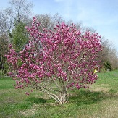
Height: 10 feet
Spread: 10 feet
Sun: Full sun

__________________________________________
Cupressocyparis leylandii (Cypress)
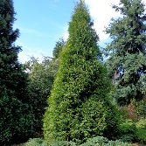
Height: 60 to 70 feet
Spread: 15 to 25 feet
Sun: Full sun

__________________________________________
Quercus alba (White Oak)
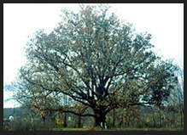
Height: 50 to 80 feet
Spread: 50 to 80 feet
Sun: Full sun

Gleditsia triacanthos inermis (Locust)
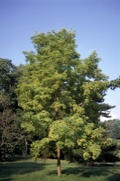
Height: 30 to 70 feet
Spread: 30 to 70 feet
Sun: Full sun

__________________________________________
Juniperus virginiana (Red Cedar)

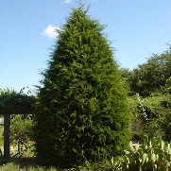
Height: 40 to 50 feet
Spread: 8 to 20 feet
Sun: Full sun

Nyssa sylvatica (Black Gum)

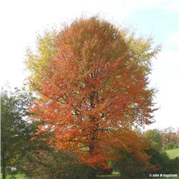
Height: 30 to 50 feet
Spread: 20 to 30 feet
Sun: Full sun to part shade

